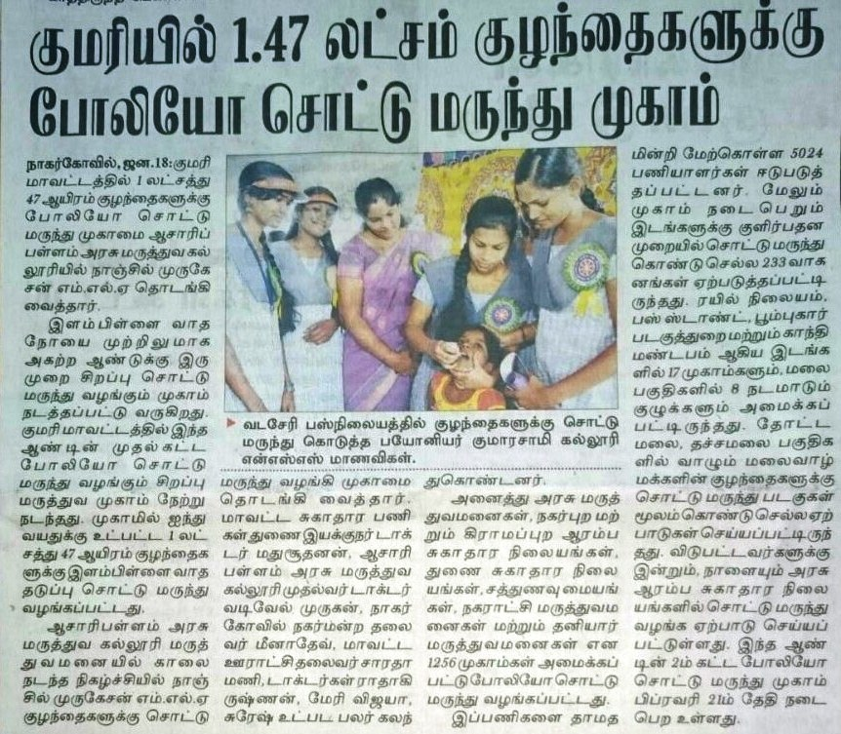

**DINAKARAN – 18.01.2016 – POLIO AWARENESS**

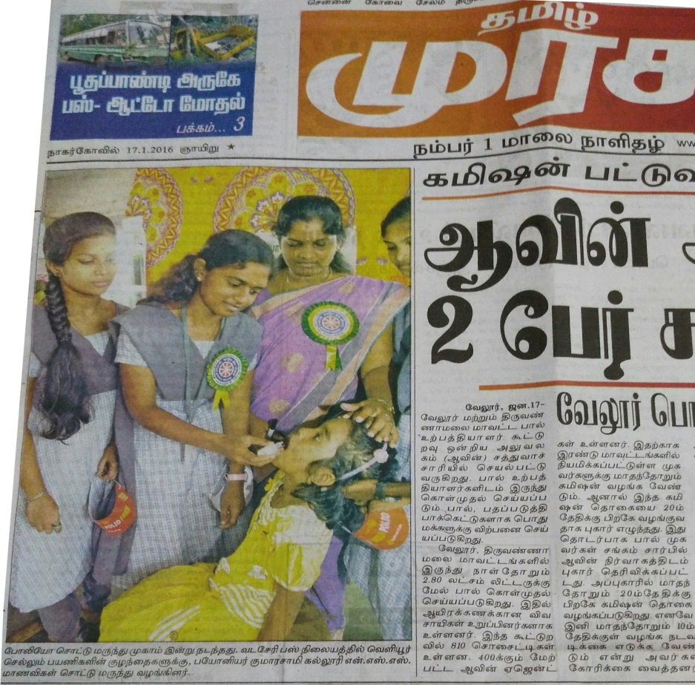

**TAMIL MURASU – 17.01.2016 (EVENING ISSUE)**

**NEWS PUBLISHED IN MALAI MALAR DATED 29.08.2016**

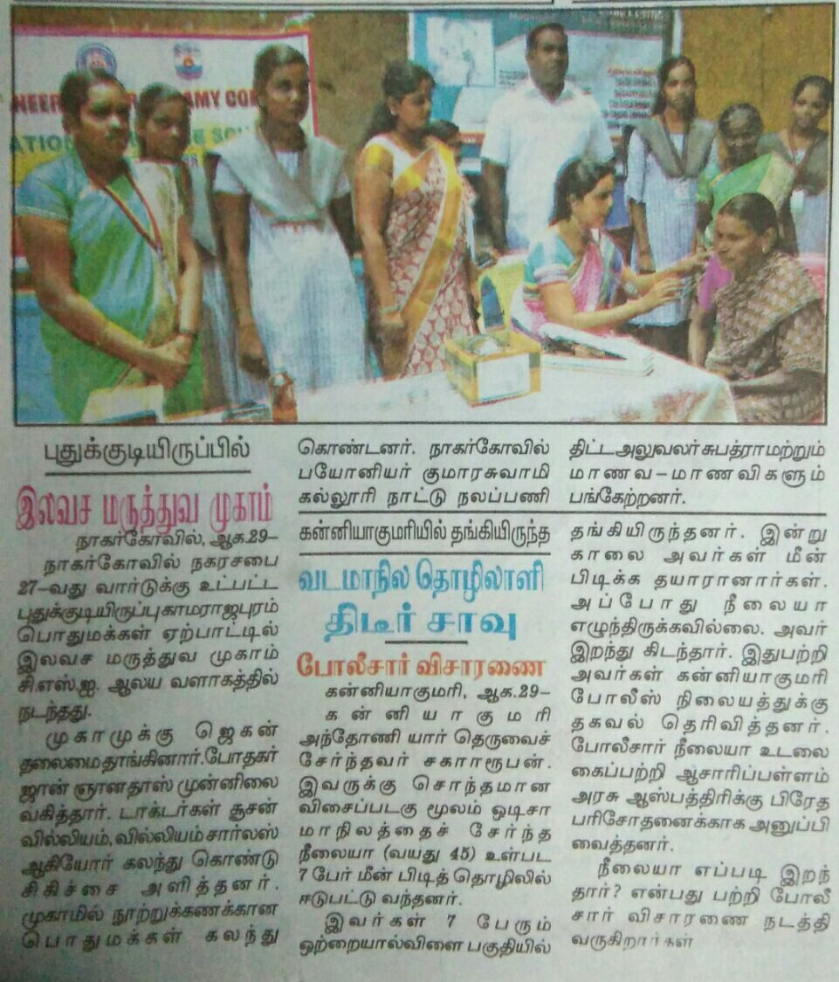

DENGUE AND MALARIA AWARENESS CAMPAIGN

**NEWS PUBLISHED IN DINA MALAR DATED 27.08.2016**

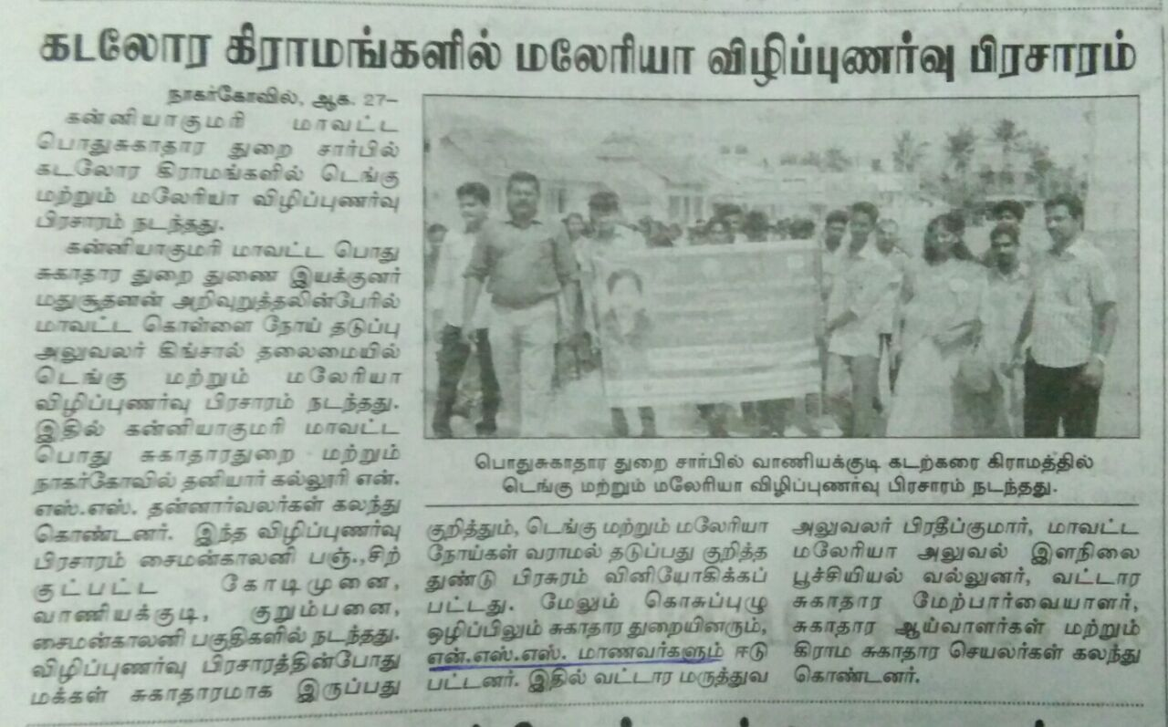

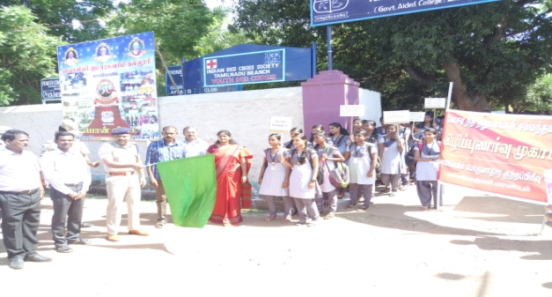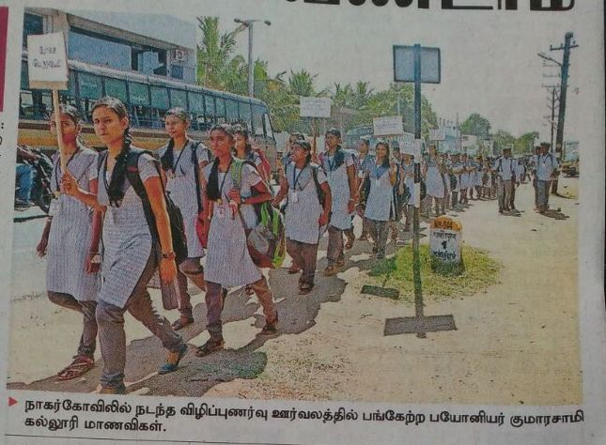

INAUGURATION OF RALLY – Financial Awareness, Published in Dinakaran dated 15.03.2017 (Wednesday)

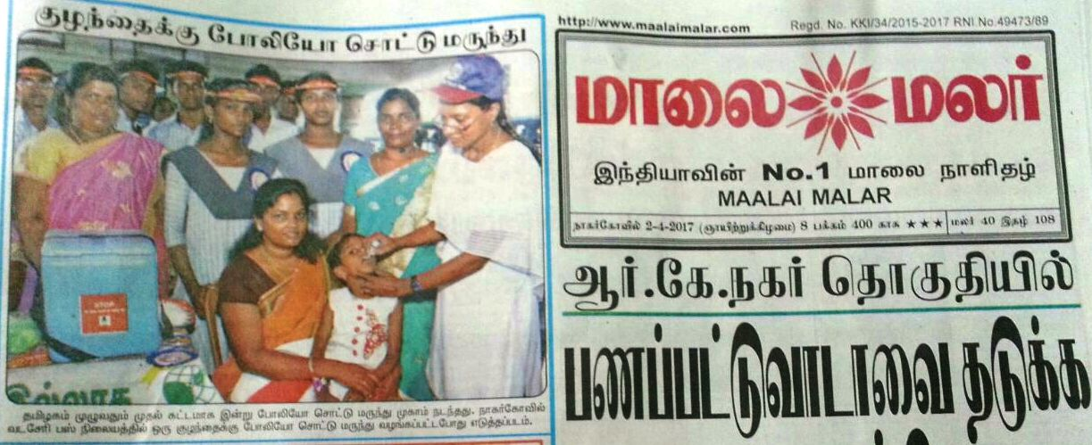

Malai Malar , Dated 02.04.2017 (Sunday), Nagercoil Issue.

Pulse Polio Awareness

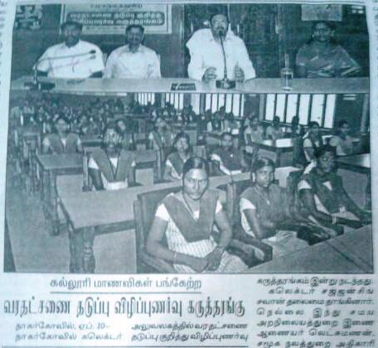

**Published in “Malai Malar” dated 10.04.2016**

**Dowry Awareness Seminar**

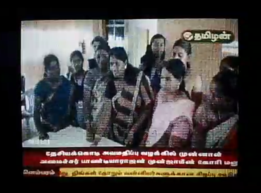

**Telecasted in “ Tamilan TV” on 10.04.2017 at 8.30 News, signature Campaign**

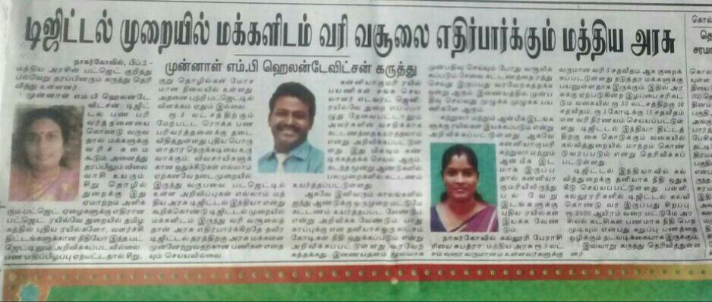

Published in Dinamalar, Dated 09.03.2016 , Opinion about Digitalisatrion

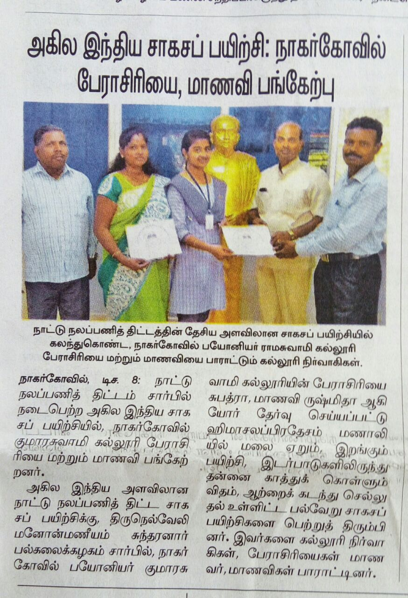

Published in News Paper , Daily Malar, Dated: 08.12.2016, National Adventure Camp Participation

